Month/Year _____________________________
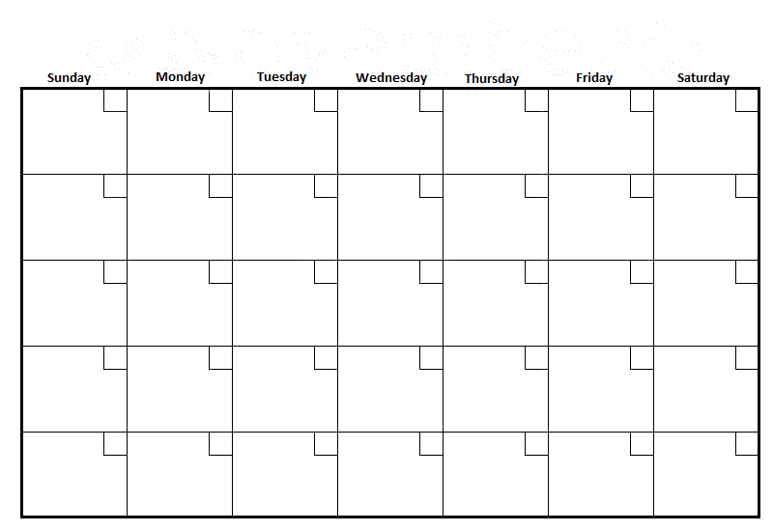
Tutor _____________________________
Monthly Tutor Calendar
FILL OUT TUTOR NAME ON TOP OF FORM. FOR EACH DAY YOU TUTOR, PLEASE WRITE IN THE APPROPRIATE DAY OF THE MONTH, HOURS YOU TUTORED, STUDENTS NAME, AND BASIC LESSON PLAN (SKILL BOOK LESSON NUMBER, REINFORCEMENT ACTIVITY, ETC.). PLEASE MAIL OR BRING TO THE OFFICE BY THE END OF EACH REPORTING MONTH. MAILDING ADDRESS IS 640 S. 6TH ST Arkadelphia, AR 71923
E-mail: cclc@suddenlinkmail.com Phone: (870) 246-1104

