Initial Student Intake
Office Notes
____In Computer

Date Assigned: _________

Tutor Assigned: ________________

ESL/Adult Literacy

Clark County Literacy Council, Inc.

Date___________________

Name_____________________________________

Address___________________________________

City_______________________ Zip____________

Home Phone Number _________________ Cell Phone Number__________________

Where do you work__________________ Unemployed Not in Labor Market

Work Phone Number _________________

Date of Birth ________________ Age____ Male_______ Female________

Country of Birth___________________ Country of Citizenship________________

Social Security Number or Drivers License Number______________________________

Married_____ Single_________ Number of Children________________

Number in Household___________________ E-mail ___________________________

Level of Education (Please check highest completed)
Less than 12th __ If less than 12th grade, what grade completed__
High School Diploma__ GED__ Non-English Diploma__ Some College__ Undergraduate__ Graduate___

Preferred Times for Tutoring (Circle all that apply)
Morning Afternoon Evenings Other_______

Monday Tuesday Wednesday Thursday Friday
Saturday Sunday Other______________

Ethnicity Please Circle One
American Indian Alaskan native Asian White Hispanic/Latino
Native Hawaiian/ Pacific Islander African American Other
Office Notes
____________________________________________________________________________________________________________________________________________________________________________________________________________________________________________________________________________________________________________________________________________________________________________

Repeated Any Grade?_______________ Which?_________________________

Has anyone in your family had difficulty with: Reading? ______ Spelling? ______

Who? ___________________________

Have you ever been tested for a learning disability or had special reading classes? _________________________________________________________________

Any reading problems?____________________________________________________

What reasons do you give for your reading difficulties?___________________________

If so, when did they begin? Grade or Age?____________________________________

Vision Assessment
Please check all that apply
______head start to ache __________eyes water _______print blur after 10 minutes
______print seem to wiggle or move after ten minutes

Spelling difficulties? _____________________________________________________

Disabled? ______________________________________________________________

Do you wear glasses? _____________________________________________________

English Primary Language?________________ If no, which Language?_____________

Please Circle the Items You Can Read.
Maps Menus Road signs Newspaper headlines
Telephone books Do you read for pleasure

Please circle who told you about the Literacy Council
TV/Radio Friend/Family Telephone Book Library
Other Volunteer Newspaper Special Event Poster
Public Relations Talk Website ProLiteracy America Dollar General Referral
Other Agency/Other Literacy Organization Probation Office

Are you required to be registered with us through a Federal, State, County or City Supervision and/or Corrections Department? Yes ___No___
If yes, name of Probation Officer: ___________________________

What are your goals? Check all that apply
______Enter employment
______Retain employment
______Improve employability skills
______Receive GED
______Enter other education and/or training
______Reduce receipt of public assistance
______Achieve work based student goal
______Obtain citizenship
______Gain citizenship skills
______Register to vote
______Vote for the first time
______Increase involvement in community activities
______Increase involvement in children’s educational activities
______Attain consumer skills
______Increase pronunciation
______Increase vocabulary
______Increase conversational fluency
______Increase oral comprehension
______Other______________________________________________________

I certify by my signature that all of the above information is true and correct to the best of my knowledge.

_______________________ _______________________
Client Signature Date

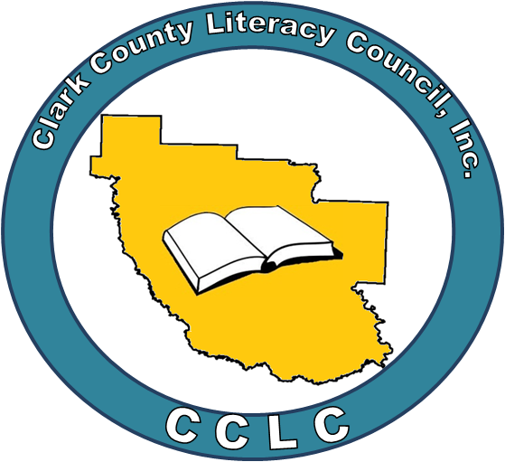

Release Form For Clients

In consideration of being interviewed and/or photographed in connection with the Clark County Literacy Council, Inc., I, _________________________________________________________, hereby agree to the following:
Yes__ No__

- I understand the video, audio, and/or still photography in which I agree to participate may be used for, but not limited to, informational, public relations, promotional, and/or fund-raising materials.
Yes__ No__

- I grant CCLC the right to copyright, use, and publicize my name, likeness, and/or video, audio, written, or spoken comments.
Yes__ No__

- I relinquish and grant to CCLC all right, title, and interest in agree that CCLC has the right to edit in any manner whatsoever without restriction. I waive any right to inspect or approve the finished product or other copy that may be used in connection therewith.

Today’s Date:___________________________
Name(print):____________________________
Address:________________________________
_______________________________________
Signature:_______________________________

